scanJig Printed set-up Instructions; Page 1 of 2
Set up instructions can also be found online at: www.scanjig.com/instructions
Video - www.scanjig.com/video
Braille formatted file - email info@scanjig.com

Product Description:
The ScanJig Pro scanning stand is designed for easy tactile positioning of both a smart device and documents for correct focus, alignment and field of view.
Once set up - the stand holds smart phones or tablets in a vertical portrait orientation and at an angle where the device's touch screen interface is facing a seated user. The stand can also hold a document, in the same vertical portrait orientation, and angle, directly behind the smart phone or tablet.
The device holder can be adjusted to position your device's rear lens to point directly at the center of the document.
After the smart device is positioned in the optimum location, stops can be applied to lock in this position. Then your phone or tablet can easily be placed in the same spot for each subsequent use.
The product's angled design takes advantage of ambient light and helps avoid shadows. If the feature is needed, the device's flash is completely unobstructed. Also, the entire product is made using white colored molded plastic which helps support larger devices.

What is stored inside the ScanJig?
- Printed Instructions – one double sided sheet.
- A Smart Device Holder and Device Shelf (extended for larger tablets) - the device will sit on the shelf.
- Inside a small plastic zip-lock bag:
  - Two Document Clips - to better hold creased documents or small items.
  - Peel and Stick Device Stops - after your mobile device is positioned the stops help hold it in place and provide an easy way to quickly use the same position again.
- Black paper card stock – provides background contrast for automatic border detection when scanning smaller items (e.g., checks, business cards, photos)

Initial Set-Up
1 To open, move the ScanJig so the latch on the front end is facing you. Place your finger under the latch and pull slightly out and up to unlatch. Open the cover all the way until it stops. The inside of the cover is the Document Bed with a shelf on the bottom and a fence on the right. Place a document on the shelf and against the fence.
2 Positioning your device camera for a full screen view of the document.
This initial set-up is done once, the optimum position for your device is then preserved by applying the peel and stick stops for subsequent uses.
Reach inside the ScanJig tray and lift the Device Holder up and out of the storage clips. The holder is about 8 inches wide by 9 inches tall. There is a large handle hole near the top edge. There are four rectangular holes along the bottom edge. With the smooth side facing you, slide the left and right edges of Device Holder into one of the four slots molded into the sides and near the front of the ScanJig tray. The slots are located just after each V shape molded protrusion. The holder will slide straight down all the way to the bottom of the tray. Two anchor clips molded into the bottom of the tray will snap into the rectangular holes on the bottom edge of the holder. To do this, push the top edge of the holder away from you and the bottom edge will then engage the clips.
Continued on back side >

Set-up Instructions; Page 2 of 2

The device holder has ten sets of holes and the shelf has two pegs that can be inserted into the holes. Hold the shelf horizontally, smooth side up, choose the set of holes that will best position your device's lens to point at the center of the document and insert the shelf into the holes.
Some tablets have a rear camera lens in the upper corner. As a result, the tablet will need to be positioned off center. The ScanJig Pro has an extended shelf to provide extra support for these tablets.
Note: When using very large tablets a folding support leg is located on the underside of the shelf.
Turn on your device and open your scanner app. Place your phone or tablet on the shelf in the portrait orientation. The top of your device will be above the top edge of the device holder and completely unobstructed with the lens pointing at the document. Note - the large hole is only a handle.
Slide your device left or right on the shelf until the document is in full view.
To adjust vertically you can move the shelf to different holes. To zoom in or out, the entire device holder assembly can be moved to a different slot.
Peel and stick stops - when your phone or tablet is in the best position, place one or two stops on the shelf in front of the device, press firmly. Also, place one stop on the device holder along the right side of the device. Press firmly.
Now your phone or tablet can easily be repositioned for each use.
Document clips - these can be used on the document bed to help hold documents that have creases.
Make sure there is good room lighting and/or turn on the device’s flash.
3 To close the ScanJig for travel or storage - remove the shelf from the device holder. Remove the device Holder from the slots and lay both flat in the tray. Remove any document clips from the document Bed. Finally close and lock the cover.

Figure 1 – ScanJig Assembly – Document Scanning Figure 2 – Adjusted to hold large tablet

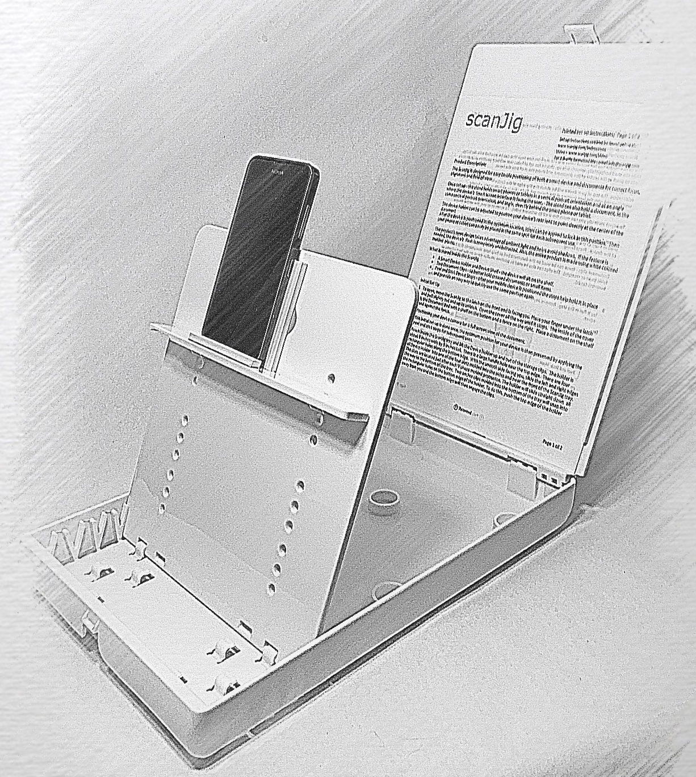
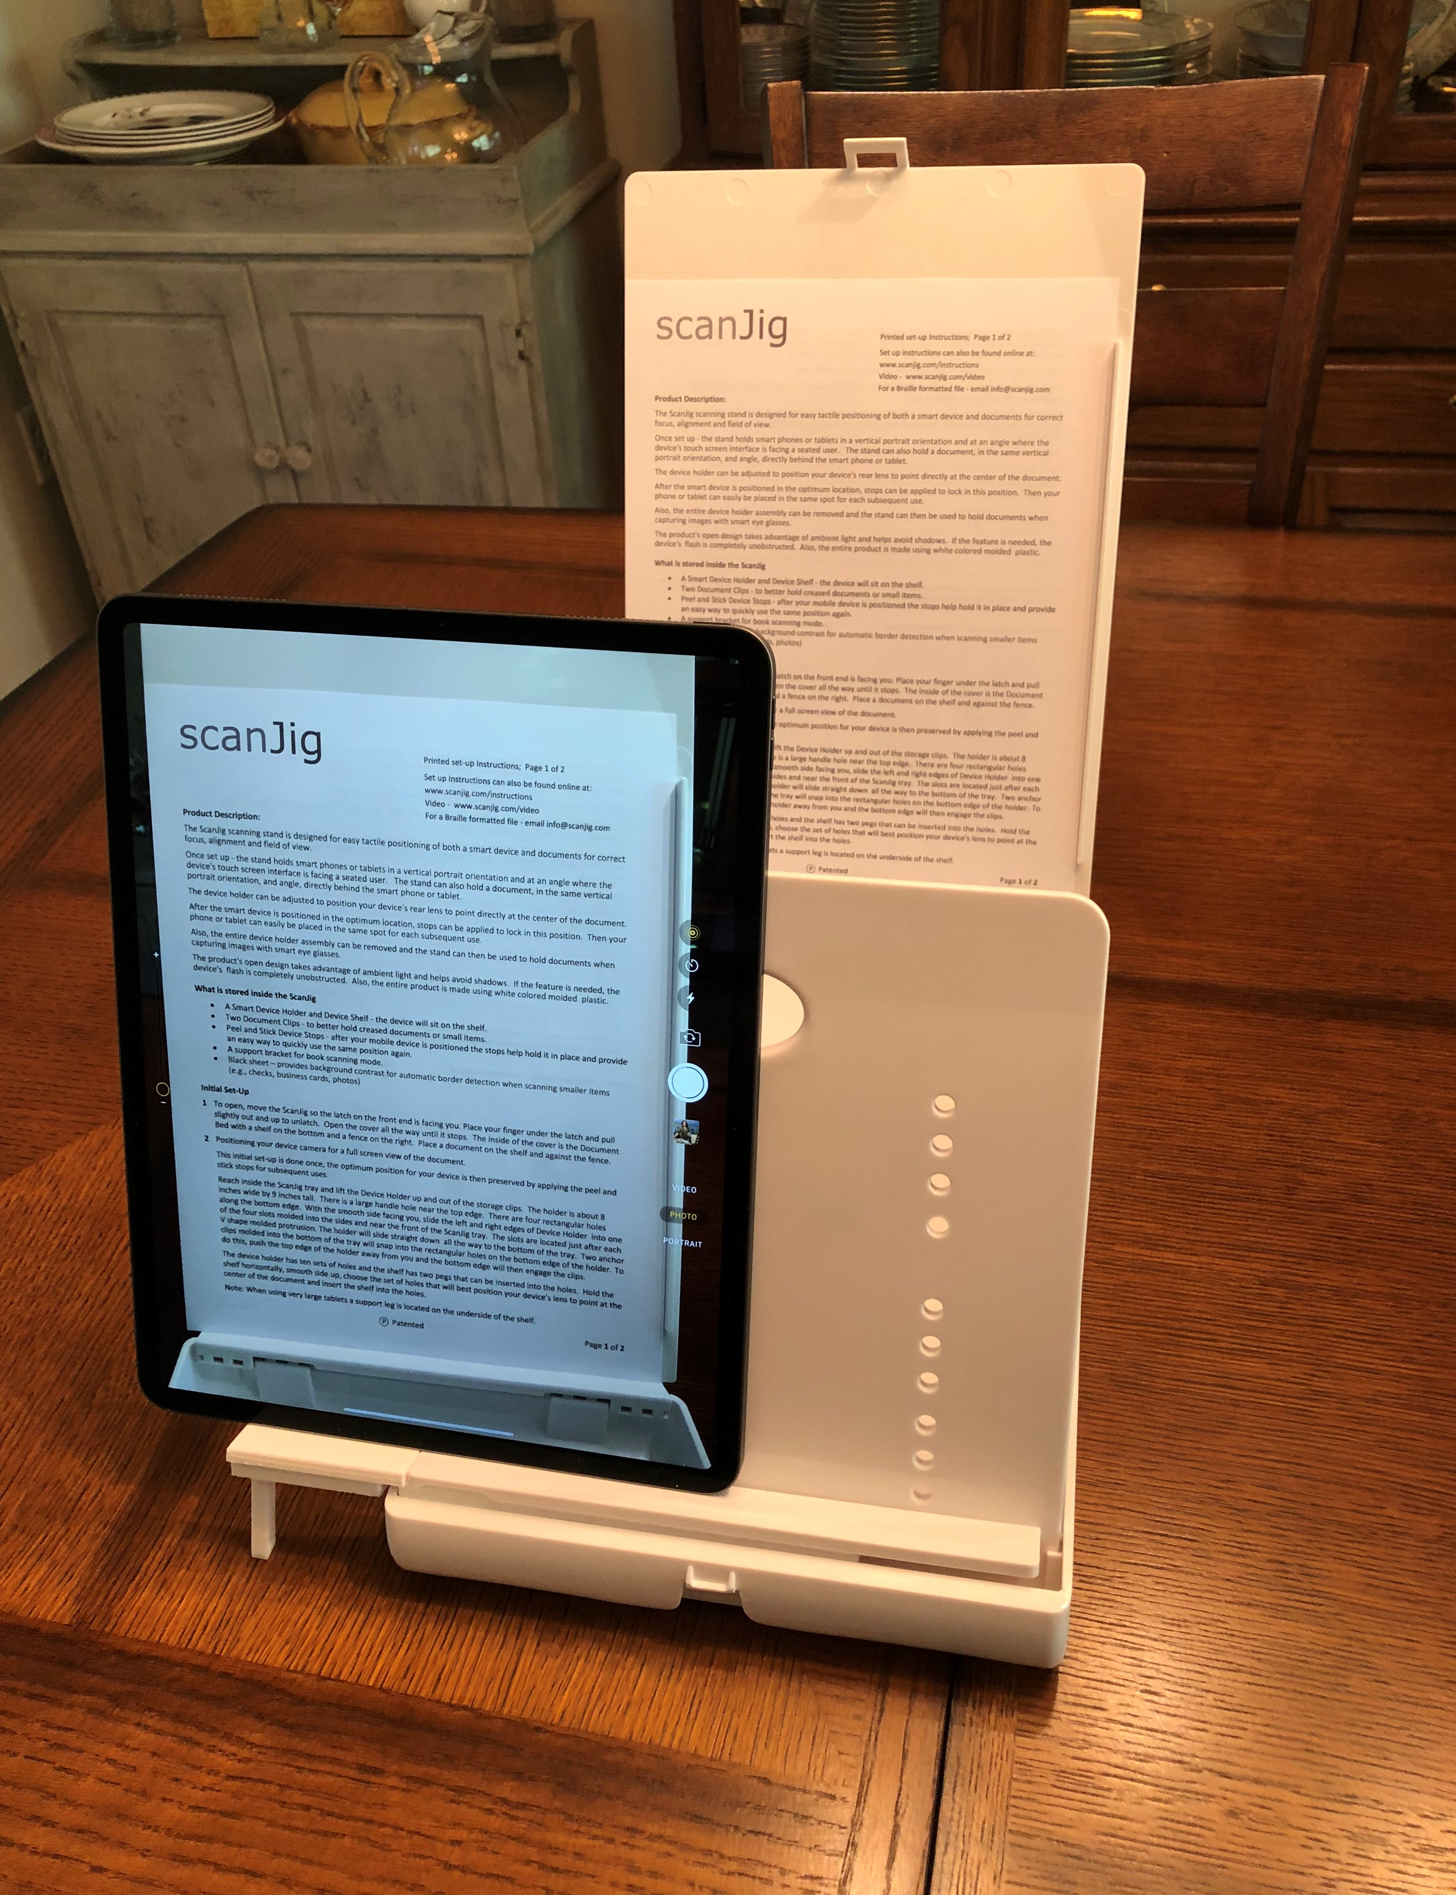
Lens - Line of Sight
Peel &
Stick Stops
Device Holder & Shelf
Slots
Anchor clips
Folding Support Leg

